**Testing of Secure File Encryption/Decryption App**

**By Muhammad Shehryar Qureshi**

**Short Description**

The Secure File Vault is a desktop app built in Python with the PyQt5 framework. It offers an easy way for users to encrypt and decrypt files through a straightforward graphical interface. When users launch the app, they see two main options: encrypt or decrypt a file and also a third option which is too generate the key.

For encryption, when a user selects a file, the app uses the Fernet module from the cryptography library to apply AES (Advanced Encryption Standard) symmetric encryption. This method ensures the data remains confidential and intact, using built-in HMAC verification. Encrypted files are saved with a .enc extension.

For decryption, users can choose any .enc file, and the app will restore the original content by reversing the encryption. The application includes popup notifications for both successful operations and error handling, which contributes to a smooth, user-friendly experience. It is designed to run locally on macOS and can be made into a standalone executable using tools like PyInstaller. This makes it accessible without needing a Python environment.

**Running the Application**

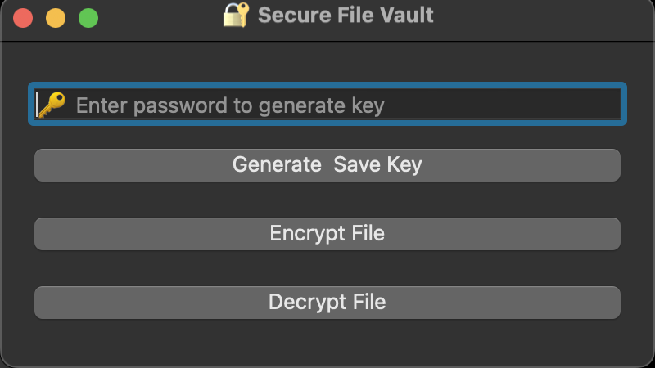

**Encrypting the file**

